SADAD EBPP Portal Administration Guide

Portal Setup and Administration Document

Table of Contents

SADAD Portal Artifacts 3

LoginPortlet.war 3

SadadLogin.jar under /opt/IBM/PortalServer/shared/app 3

RulesConfiguration-{VERSION}.war 4

# SADAD Portal Artifacts

SADAD EBPP Portal contains the following custom developed modules.

* LoginPortlet.war
* RulesConfiguration-{VERSION}.war
* RulesDefinition-{VERSION}.war
* SadadOperatorWorkbench-{VERSION}.war
* SadadPortalUsers-{VERSION}.war
* SadadPortlets-{VERSION}.war

## LoginPortlet.war

The login module was customized version of IBM Login portlet, the portlet customized for version 6.0 of IBM WebSphere Portal. The same module was deployed on Portal version 8.0 and now to Portal 9.0 without any further modification since its initial customization.

## SadadLogin.jar under /opt/IBM/PortalServer/shared/app

SadadLogin.jar contains only single class which is an extension of com.ibm.portal.auth.ExplicitLoginFilter for the customized behavior of SADAD Login. SadadLoginFilter class checks the password age and terms and condition acceptance. The user is redirected to Term and Condition page if user did not accept the terms and condition till login, and if password is aged around 60 days the user will be redirected to change password page.

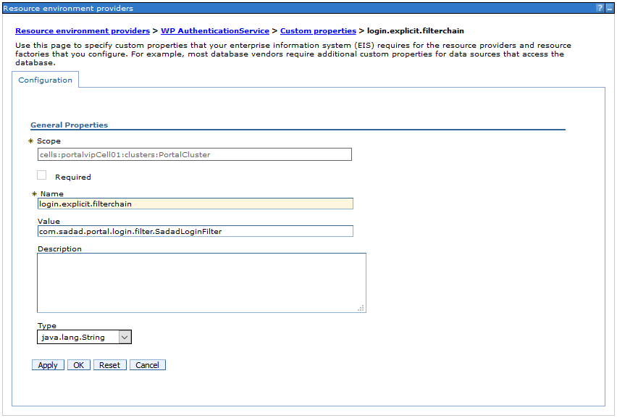

Figure 1 – Configuration for SADAD Login Filter

## RulesConfiguration-{VERSION}.war

The RulesConfiguration WAR contains the following two portlets.

1. Bank Rules Configuration Portlet
2. Biller Rules Configuration Portlet

Tace logger

Portlet Configurations

Backend Service Calls

## RulesDefinition-{VERSION}.war

The RulesDefinition WAR contains the following two portlets.

1. Rules Definition Portlet
2. Rules Definition Channels Portlet